**BLOGGING WEBSITE**

**A PROJECT REPORT**

***Submitted by***

**Viraj bhatti – 91900938052**

**Vansh thakrar– 91900938037**

**Deep kaneriya – 91900938028**

**Pal dadhaniya– 91900938027**

**Ridham thoriya-91900938126**

***In partial fulfilment for the award of the degree of***

**DIPLOMA ENGINEERING**

***in***

**Computer Engineering**



**Marwadi University, Rajkot**

**Faculty of Diploma Studies**

Computer Engineering Department

**2020-21**

**CERTIFICATE**

This is to certify that the project entitled **BLOGGING WEBSITE** has been carried out by **VIRAJ BHATTI (91900938052)** under my guidance in partial fulfilment of the degree of Diploma Engineering in Computer Engineering (5th Semester) of Marwadi University, Rajkot during the academic year 2020-21.

Date :___________________

**Internal Guide Head of the Department**

Prof. Guide Name Head of Department

Assistant Professor Computer Engineering



**Marwadi University, Rajkot**

**Faculty of Diploma Studies**

Computer Engineering Department

**2020-21**

**CERTIFICATE**

This is to certify that the project entitled **BLOGGING WEBSITE** has been carried out by **DEEP KANERIYA (91900938028)** under my guidance in partial fulfilment of the degree of Diploma Engineering in Computer Engineering (5th Semester) of Marwadi University, Rajkot during the academic year 2020-21.

Date : ____________________

**Internal Guide Head of the Department**

Prof. Guide Name Head of Department

Assistant Professor Computer Engineering



**Marwadi University, Rajkot**

**Faculty of Diploma Studies**

Computer Engineering Department

**2020-21**

**CERTIFICATE**

This is to certify that the project entitled  **BLOGGING WEBSITE** has been carried out by **VANSH THAKRAR (91900938037)** under my guidance in partial fulfilment of the degree of Diploma Engineering in Computer Engineering (5th Semester) of Marwadi University, Rajkot during the academic year 2020-21.

Date : ____________________

**Internal Guide Head of the Department**

Prof. Guide Name Head of Department

Assistant Professor Computer Engineering



**Marwadi University, Rajkot**

**Faculty of Diploma Studies**

Computer Engineering Department

**2020-21**

**CERTIFICATE**

This is to certify that the project entitled **BLOGGING WEBSITE** has been carried out by **PAL DADHANIYA (91900938027)** under my guidance in partial fulfilment of the degree of Diploma Engineering in Computer Engineering (5th Semester) of Marwadi University, Rajkot during the academic year 2020-21.

Date : ____________________

**Internal Guide Head of the Department**

Prof. Guide Name Head of Department

Assistant Professor Computer Engineering



**Marwadi University, Rajkot**

**Faculty of Diploma Studies**

Computer Engineering Department

**2020-21**

**CERTIFICATE**

This is to certify that the project entitled **BLOGGING WEBSITE** has been carried out by **Ridham Thoriya (91900938126)** under my guidance in partial fulfilment of the degree of Diploma Engineering in Computer Engineering (5th Semester) of Marwadi University, Rajkot during the academic year 2020-21.

Date : ____________________

**Internal Guide Head of the Department**

Prof. Guide Name Head of Department

Assistant Professor Computer Engineering

**Contents**

**Acknowledgements I**

**Abstract II**

**List of Figures III**

1. **Introduction 2**
   1. Document purpose 2
   2. Product scope 2
   3. Intended audience and document overview 2
   4. Definitions and abbreviations 2
   5. Document conventions 2
   6. References and acknowledgments 3
2. **Overall description 4**
   1. Product perspective 4
   2. Product functionality 4
   3. Users and characteristics 4
   4. Operating environment 4
   5. Design and implementation constraints 5
   6. User documentation 5
   7. Assumptions and dependencies 5
3. **Specific requirements 6**
   1. External interface requirements 6
   2. Functional requirements 7
   3. Behavior requirements 7
4. **Other non-functional requirements 8**
   1. Performance requirements 8
   2. Safety and security requirements 8
   3. Software quality attributes 8
5. **Other requirements 9**

**Appendix A – Data Dictionary 11**

**Appendix B – Plagiarism Report 12**

**Appendix C – User Manual 15**

**Acknowledgements**

I would like to express my sincere gratitude to several individuals and organizations for supporting me throughout my Graduate study. First, I wish to express my sincere gratitude to my guide, **Prof. SMIT THACKER**, for his enthusiasm, patience, insightful comments, helpful information, practical advice and unceasing ideas that have helped me tremendously at all times in my research and writing of this thesis. His immense knowledge, profound experience and professional expertise in Hyper text markup language has enabled me to complete this research successfully. Without his support and guidance, this project would not have been possible. I could not have imagined having a better supervisor in my study.

I also wish to express my sincere thanks to the University of marwadi for accepting me into the graduate program. I am also grateful to the following university staff: **Anand Trivedi , Pratik Chauhan, Sumit Makwana for their consistent support and assistance.**

Finally, last but not least; also to everyone in the institute for project it was great sharing premises with all of you during last 3 years.

Thanks for all your encouragement.

Viraj Bhatti

Vansh Thakrar

Pal Dadhaniya

Deep Kaneriya

**Abstract**

The "Online Blogging System" has been developed to override the problems prevailing in the practicing manual system. This software is supported to eliminate and in some cases reduce the hardships faced by this existing system. Moreover this system is designed for the particular need of the personal use to carry out operations in a smooth and effective manner.

This website is reduced as much as possible to avoid errors while entering the data. It also provides error message while entering invalid data. No formal knowledge is needed for the user to use this system. Thus by this all it proves it is user friendly. Online Blogging System, as described above, can lead to error free, secure, reliable and fast management system. It can assist the user to concentrate on their other activities rather to concentrate on the record keeping. Thus it will help organization in better utilization of resources.

List Of Figures

Sr. no. Figures Page No.

1.1.1 Use Case Diagram IX

1.1.2 E R Diagram X

1.1.3 Activity Diagram XI

1.1.4 Sequence Diagram XII

1.1.5 DFD Diagram XIII

1.1.6 Class Diagram XIV

1.1.7 Flow Chart XVI

Proposed use case diagram for our system is:-

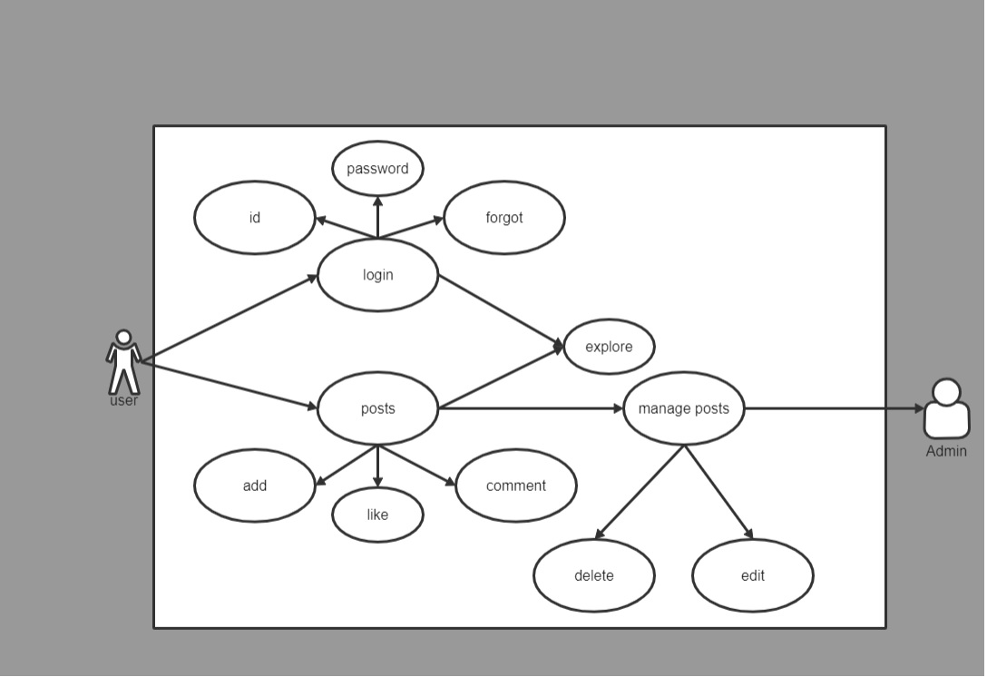

Figure 1.1.1 Use Case Diagram

Proposed Entity-Relationship diagram for our system is:-

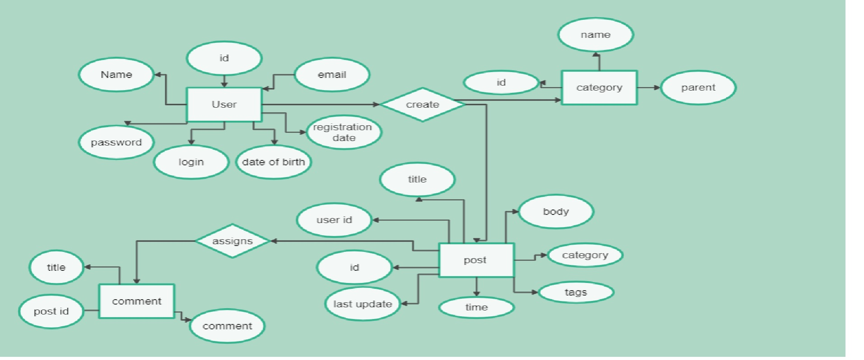

Figure 1.1.2 ER Diagram

Proposed Activity diagram for our system is:-

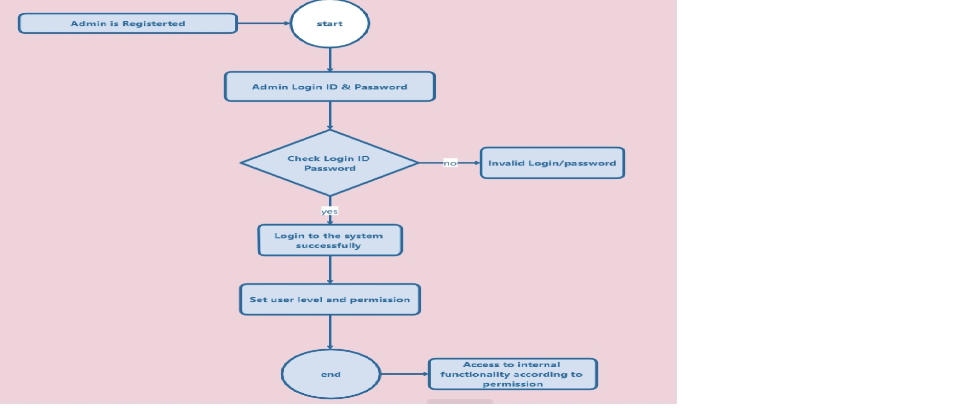

Figure 1.1.3 Activity Diagram

Proposed Sequence diagram of our system is:- 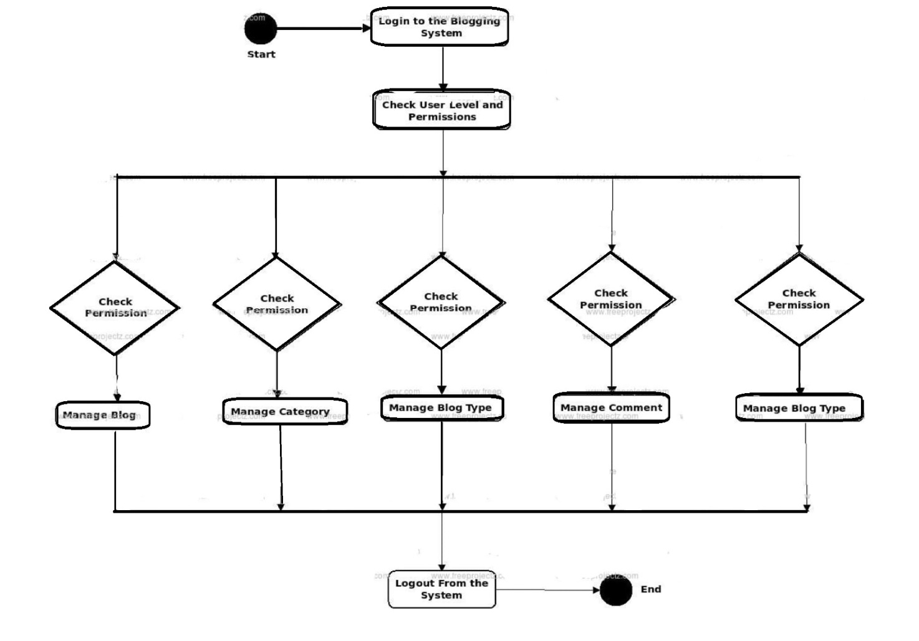

Figure 1.1.4 Sequence Diagram

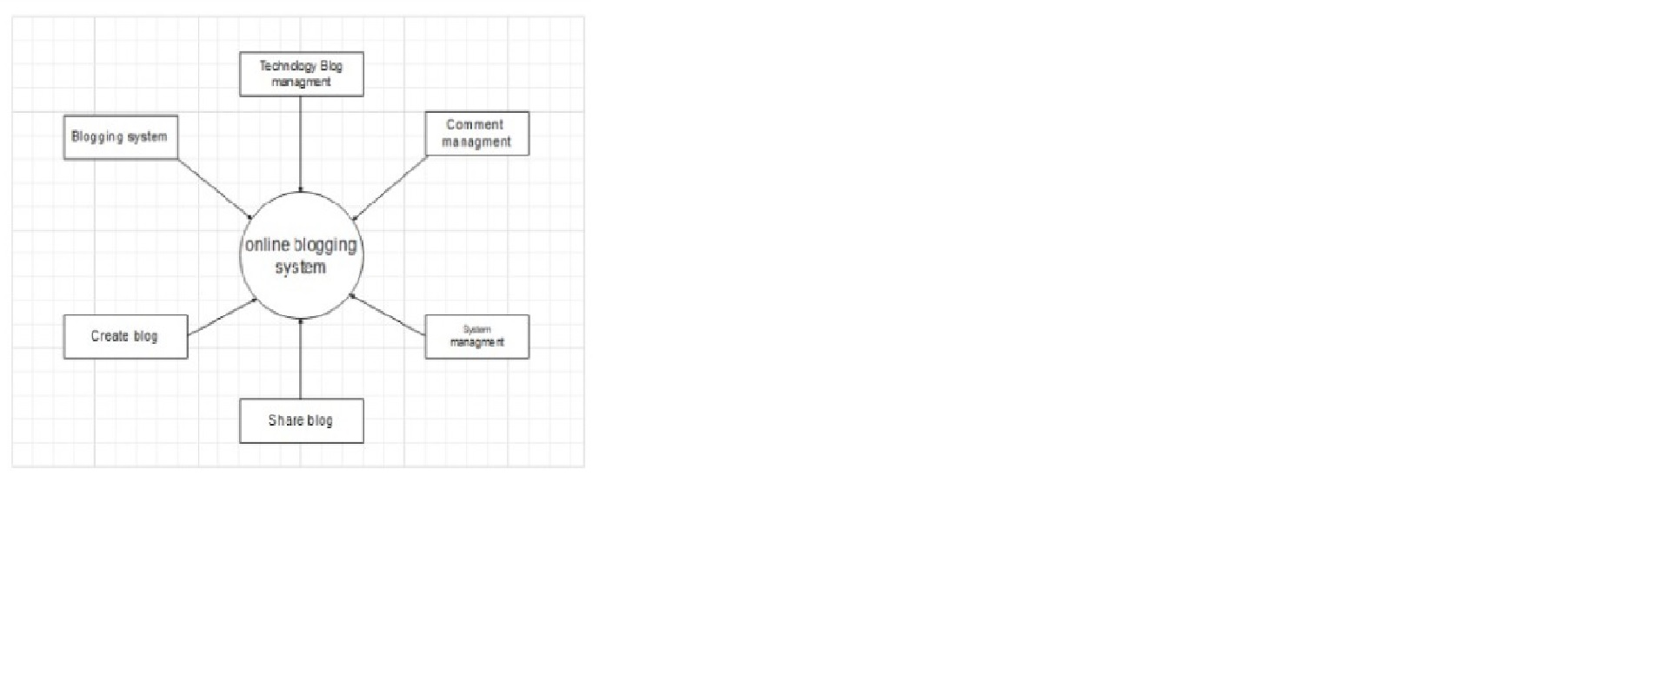Proposed diagram for our system is:-

Figure 1.1.5 DFD Diagram

Class Diagram

Proposed Flowchart for our system is:-

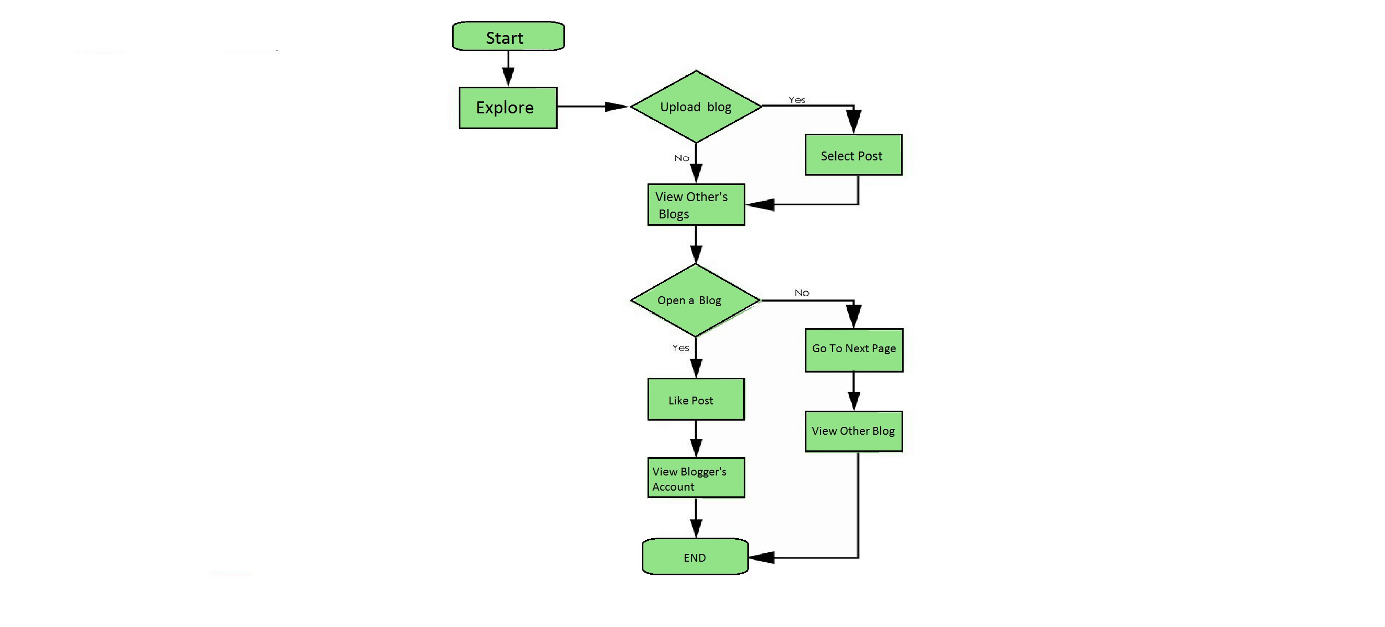

Figure 1.1.7 Flowchart

1. **Introduction**

## Document Purpose

The purpose of this document is to build an online blogging website that helps bloggers to show off their skills.

## Product Scope

The purpose of the online Blogging management system is to blog and to create a convenient and easy-to-use application for users, trying to shoot the blogs and post. We will have a database server supporting hundreds of bloggers around the world . Above all, we hope to provide a comfortable user experience along with the best features available.

## Intended Audience and Document Overview

This project is a prototype for the blogging management system and it is restricted within the country premises. This has been implemented under the guidance of college professors. This project is useful for the blogging management team and as well as to the viewers.

## Definitions, and Abbreviations

A blog is an online journal or informational website displaying information in reverse chronological order, with the latest posts appearing first, at the top. It is a platform where a blogger or a group of blogger share their views on an individual subject.

## Document Conventions

This document is used for to understand the flow of the system. It described the system characteristics, flow of software, how to use the system. Document is mainly used for user to understand what about system do, what is the system used for and why this system being developed.

## References and Acknowledgments

[UML Use Case Diagram Symbols (edrawsoft.com)](https://www.edrawsoft.com/uml-use-case-symbols.html)

[ER Diagram Symbols and Notations | Edraw (edrawsoft.com)](https://www.edrawsoft.com/er-diagram-symbols.html)

[UML Class Diagram Symbols (edrawsoft.com)](https://www.edrawsoft.com/uml-class-symbols.html)

[UML Sequence Diagram Symbols (edrawsoft.com)](https://www.edrawsoft.com/uml-sequence-symbols.html)

[Data Flow Diagram (DFD) Symbols - EdrawMax (edrawsoft.com)](https://www.edrawsoft.com/data-flow-diagram-symbols.html)

[UML Activity Diagram Symbols (edrawsoft.com)](https://www.edrawsoft.com/uml-activity-symbols.html)

1. **Overall Description**

## Product Perspective

1. A distributed Blogging database system stores the following information.
2. **Blog details:**  
   It includes the copyright of the blogger and their profiles, along with the bloggers history of travelling.
3. **Viewing description:**  
   It includes likes, comments and location of the blog. That information may be used for keeping the records of the blogs for any other kind of information.

## Product Functionality

### Blog Post Archive

### RSS Feed

### Comment System

### Search

### Contact Method

## Users and Characteristics

* Users of the system should be able to retrieve information of cities with the given date/time of travel from the database. The system will support two types of user privileges, Viewers and Bloggers. Viewers will have access to Viewers functions, and the Bloggers will have access to both Viewers and Bloggers management functions.
* The Viewers should be able to do the following functions:
* Search for a blog of specific location.
* like
* comment
* contact blogger
* visit blogger profile
* The Blogger should have following management functionalities:
* Add/Delete his blog
* Add a new location
* Update locations specifications
* Add a new topic for blogging
* Update his current location.

## Operating Environment

* Operating environment for the blogging management system is as listed below.
* distributed database
* client/server system
* Operating system: Windows.
* platform: Html/css

## Design and Implementation Constraints

Requires an Active internet connection.

Location should be turned on while using our webpage.

Web Browser should be required.

## User Documentation

In this the visitor can only see blogs of other people but can’t change anything in blogs that are posted by bloggers and bloggers can not post irrelated and sensitive content. And users that are not signed up are not allowed to post, comment on any blogs. No copyrighted contents should be posted by bloggers.

## Assumptions and Dependencies

Let us assume that this is a distributed Blogging management system and it is used in the following application:

* A request for post and delete of a Blog.
* Calculation of bloggers in a specific location (most frequent bloggers) and calculating appropriate likes and comments on any post.

**3.specific Requirements**



## External Interface Requirements

### User Interfaces

Proposed system is a Html website. Additional languages may be used to improve the appearance of the Website. • User need to login or register itself with email id and password. Then he/she Can see our website and can see other content. User have their own profile built in after login. They can have the access to see someone’s content also.

### Hardware Interfaces

* Windows.
* A browser which supports HTML & CSS
* Mobile phones – Android OS

### Software Interfaces

Following are the software used for the blogging management.

|  |  |
| --- | --- |
| **Software used** | **Description** |
| Operating system | We have chosen Windows operating system for its best support and user-friendliness. |
| Database | To save the blog records, blogger records we have chosen SQL  database. |
| HTML | To implement the project we have chosen HTML language for its more interactive support. |

### 

### Communications Interfaces

This project supports all types of web browsers. We are using simple electronic forms for viewers communication with bloggers and devlopers. And some social media apps through which they can communicate.

## Functional Requirements

Display output: Mainly the blogs can be displayed after login form is completed.

Language selection: Language selection is used to the change the language as an input and output.

Login / Sign Up: For one user the login-state can be either logged in, if not logged in then Create the user ID.

Suggestions & feedback: This function is used to any query and some types of changes suggestion and giving feedback to the administrator.

## Behaviour Requirements

### Use Case View

User:

* User post photos and video
* user can see the other blogs
* user can like comment
* user can login/sign up

admin:

* admin can manage others post
* admin can delete and edit if some content are sensitive or improper
* admin can directly contact anyone with the information provided by user

**4. Other Non-functional Requirements**



## Performance Requirements

## The website will be loaded and will be usable within 5 seconds

## You need an active internet connection

## Safety and Security Requirements

If there is extensive damage to a wide portion of the database due to catastrophic failure, such as a disk crash, the recovery method restores a past copy of the database that was backed up to archival storage (typically tape) and reconstructs a more current state by reapplying or redoing the operations of committed transactions from the backed up log, up to the time of failure.

Security systems need database storage just like many other applications. However, the special requirements of the security market mean that vendors must choose their database partner carefully.

## Software Quality Attributes

* **AVAILABILITY:** The blog should be available to all viewers surfing on the website.
* **CORRECTNESS:** The blog should reach post from correct post terminal and should reach the correct database.
* **MAINTAINABILITY:** The bloggers and viewers should maintain correct locations.

**Appendix A– Plagiarism Report**

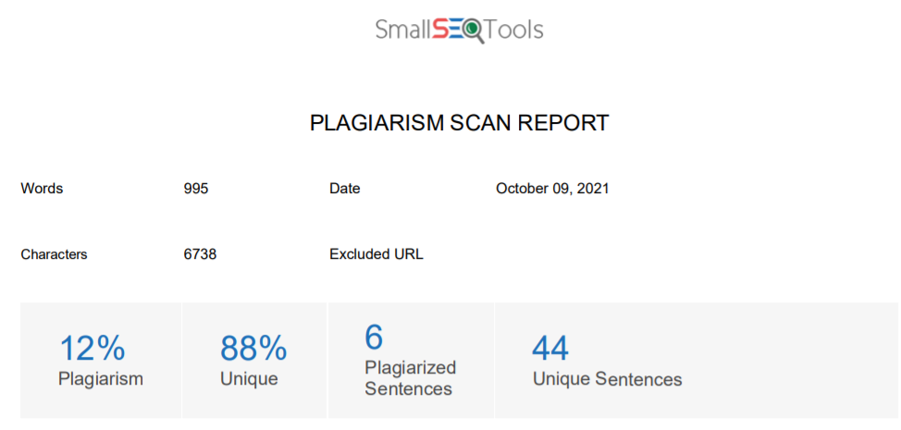

1.1 Document Purpose  
The purpose of this document is to build an online blogging website that helps bloggers to show off their skills.  
1.2 Product Scope  
The purpose of the online Blogging management system is to blog and to create a convenient and easy-to-use application for users, trying to shoot the blogs and post. We will have a database server supporting hundreds of bloggers around the world . Above all, we hope to provide a comfortable user experience along with the best features available.  
1.3 Intended Audience and Document Overview  
This project is a prototype for the blogging management system and it is restricted within the country premises. This has been implemented under the guidance of college professors. This project is useful for the blogging management team and as well as to the viewers.  
1.4 Definitions, and Abbreviations  
A blog is an online journal or informational website displaying information in reverse chronological order, with the latest posts appearing first, at the top. It is a platform where a blogger or a group of blogger share their views on an individual subject.  
1.5 Document Conventions  
This document is used for to understand the flow of the system. It described the system characteristics, flow of software, how to use the system. Document is mainly used for user to understand what about system do, what is the system used for and why this system being developed  
2. Overall Description  
2.1 Product Perspective  
1. A distributed Blogging database system stores the following information.  
2. Blog details:  
It includes the copyright of the blogger and their profiles, along with the bloggers history of travelling.  
3. Viewing description:  
It includes likes, comments and location of the blog. That information may be used for keeping the records of the blogs for any other kind of information.  
2.2 Product Functionality  
¬ Blog Post Archive  
¬ RSS Feed  
¬ Comment System  
¬ Search  
¬ Contact Method  
2.3 Users and Characteristics  
¬ Users of the system should be able to retrieve information of cities with the given date/time of travel from the database. The system will support two types of user privileges, Viewers and Bloggers. Viewers will have access to Viewers functions, and the Bloggers will have access to both Viewers and Bloggers management functions.  
¬ The Viewers should be able to do the following functions:  
• Search for a blog of specific location.  
• like  
• comment  
• contact blogger  
• visit blogger profile  
¬ The Blogger should have following management functionalities:  
• Add/Delete his blog  
• Add a new location  
• Update locations specifications  
• Add a new topic for blogging  
• Update his current location.  
2.4 Operating Environment  
¬ Operating environment for the blogging management system is as listed below.  
• distributed database  
• client/server system  
• Operating system: Windows.  
• platform: Html/css  
2.5 Design and Implementation Constraints  
Requires an Active internet connection.  
Location should be turned on while using our webpage.  
Web Browser should be required.  
2.6 User Documentation  
In this the visitor can only see blogs of other people but can’t change anything in blogs that are posted by bloggers and bloggers can not post irrelated and sensitive content. And users that are not signed up are not allowed to post, comment on any blogs. No copyrighted contents should be posted by bloggers.  
2.7 Assumptions and Dependencies  
Let us assume that this is a distributed Blogging management system and it is used in the following application:  
• A request for post and delete of a Blog.  
• Calculation of bloggers in a specific location (most frequent bloggers) and calculating appropriate likes and comments on any post.  
3.specific Requirements  
3.1 External Interface Requirements  
3.1.1 User Interfaces  
Proposed system is a Html website. Additional languages may be used to improve the appearance of the Website. • User need to login or register itself with email id and password. Then he/she Can see our website and can see other content. User have their own profile built in after login. They can have the access to see someone’s content also.  
3.1.2 Hardware Interfaces  
♣ Windows.  
♣ A browser which supports HTML & CSS  
♣ Mobile phones – Android OS  
3.1.3 Software Interfaces  
Following are the software used for the blogging management.  
Software used Description  
Operating system We have chosen Windows operating system for its best support and user-friendliness.  
Database To save the blog records, blogger records we have chosen SQL  
database.  
3.1.4 Communications Interfaces  
This project supports all types of web browsers. We are using simple electronic forms for viewers communication with bloggers and devlopers. And some social media apps through which they can communicate.  
3.2 Functional Requirements  
Display output: Mainly the blogs can be displayed after login form is completed.  
Language selection: Language selection is used to the change the language as an input and output.  
Login / Sign Up: For one user the login-state can be either logged in, if not logged in then Create the user ID.  
Suggestions & feedback: This function is used to any query and some types of changes suggestion and giving feedback to the administrator.  
3.3 Behaviour Requirements  
3.3.1 Use Case View  
User:  
• User post photos and video  
• user can see the other blogs  
• user can like comment  
• user can login/sign up  
admin:  
• admin can manage others post  
• admin can delete and edit if some content are sensitive or improper  
• admin can directly contact anyone with the information provided by user  
4.2 Safety and Security Requirements  
If there is extensive damage to a wide portion of the database due to catastrophic failure, such as a disk crash, the recovery method restores a past copy of the database that was backed up to archival storage (typically tape) and reconstructs a more current state by reapplying or redoing the operations of committed transactions from the backed up log, up to the time of failure.  
4.3 Software Quality Attributes  
♣ AVAILABILITY: The blog should be available to all viewers surfing on the website.

**Appendix B – User Manual**